Hackathon Marketplace Builder - Our Journey Begins! 🚀

🚀 **Day 1: Laying the Foundation for My E-Commerce Marketplace Project** 🌐

As I embark on my e-commerce marketplace journey, I’m thrilled to share the strategic steps I’ve taken to lay a solid foundation for my project. Below is a summary of the process:

Step # 1 – Choose a Marketplace Type

I select General E-Commerce Marketplace. Aim to offer a wide range of products, reduce limited access, build a trust and provide premium quality to customer. Customize the order, ease the Replacement and Return Policy.

Step # 2 – Define Your Business Goals

1. Our marketplace aims to provide easy access to a wide range of products, saving customers time and effort while supporting small and medium businesses with customized packaging solutions.
2. Target audience are Shopkeepers, Home Cooks, Restaurants, Caterers.
3. Product we serve Grocery items i.e., Broad range of Masala Product
4. Quality, Customizable products, fast delivery, Rewards & Discounts, Secure payments, Flexible orders

Step # 3 – Data Schema:

1. Products, Customers, Cart, Orders, Payments, Delivery, Shipment & Tracking, Reviews & Ratings
2. Draw a Schema diagram in which describe Entity Relationship
3. Describe Key Fields of every Entities

Sir Zia Khan | Sir [Daniyal Nagori](https://www.linkedin.com/in/daniyalnagori/) | Sir [Ameen Alam](https://www.linkedin.com/in/ameen-alam/) | Sir Muhammad Anas Seth | Sir [Asharib Ali](https://www.linkedin.com/in/asharibali/) | Sir [Muhammad Qasim](https://www.linkedin.com/in/sirqasim/) |Sir [Okasha Aijaz](https://www.linkedin.com/in/okasha-aijaz/) | Sir Mubashir Ali

[#Hackathon3](https://www.linkedin.com/feed/hashtag/?keywords=hackathon3&highlightedUpdateUrns=urn%3Ali%3Aactivity%3A7285302816556859393) [#Ecommerce](https://www.linkedin.com/feed/hashtag/?keywords=ecommerce&highlightedUpdateUrns=urn%3Ali%3Aactivity%3A7285302816556859393) [#WebDevelopment](https://www.linkedin.com/feed/hashtag/?keywords=webdevelopment&highlightedUpdateUrns=urn%3Ali%3Aactivity%3A7285302816556859393) [#GIAIC](https://www.linkedin.com/feed/hashtag/?keywords=giaic&highlightedUpdateUrns=urn%3Ali%3Aactivity%3A7285302816556859393) [#FrontendDevelopment](https://www.linkedin.com/feed/hashtag/?keywords=frontenddevelopment&highlightedUpdateUrns=urn%3Ali%3Aactivity%3A7285312794202095618)

**Step 1: Choose Your Marketplace Type:**

I choose a marketplace which belong to both **E- Commerce** & **Quick Commerce** because my product is based on kitchen food product i.e., All type of Garam Masala. Name of my Marketplace will be

1. SpicesBlend.com
2. PowdernSpices.com
3. SpiceMart.com

**Primary Purpose:**

Primary purpose of my Marketplace is to provide all range of Masala Products at one place. Customer can find wide range of product in customized manner. This website will help our customer with a variety of package which make my website very unique. In my store I give special masala mix (ready to insert in dishes during cooking) on every sizes of dishes (500 gm, 1 kg, 2 kg). Customer faces the quantity of ingredient during cooking, I solve this issues with this package.

**Step 2: Define Your Business Goals:**

1. **What problem does your marketplace aim to solve?**

My aims to make this marketplace is to solve the problem of limited access of products in their areas so customer can find selected product in a single location and get it on the door step with the saving time and effort. It also helps in small and medium sized business who can buy product with customized packaging. In future, I will also add some imported product in the store to reduce the limited access of such products which are not buy easily in Pakistan.

1. **Who is your target audience?**
2. Shopkeeper - Who prefer shopping online and want access to high-quality products delivered to their doorsteps.
3. Home Cooks - who enjoy cooking at home but may not always have the time or knowledge to measure out ingredients for each recipe. They need premixed or ready-to-use masala mix for their dishes.
4. Restaurants, Caterers & Small Food Business - Small-scale food businesses that require bulk quantities of specific masalas for their dishes. They need Affordable and consistent high-quality masala mixes in larger for business operations.
5. **What products or services will you offer?**

**Products:** Grocery items i.e., Masala Product. A wide range masala product like individual masala , Special Masala Premix , customize masala premix etc

1. **What will set your marketplace apart?**

**Quality:** Provide Premium quality products

**Customizable products:** Masala Premix as per customer need, Special Masala for dishes

**Delivery Time:** Deliver product within 2 - 4 hours on the same day (on the basis of quantity and location)

**Rewards & Discounts:** Loyalty Card (to get discount & Free Delivery on the minimum order around 3000 Rs./=) , Valued & Regular customers

**Security:** Secure payment & live tracking

**Flexible Order:** Replacement & Return Policy (Terms & Conditions)

**Step 3: Create a Data Schema**

1. **Identify the Entities in Your Marketplace:**
2. Products
3. Customers
4. Cart
5. Orders
6. Payments
7. Delivery
8. Shipment & Tracking
9. Reviews & Ratings

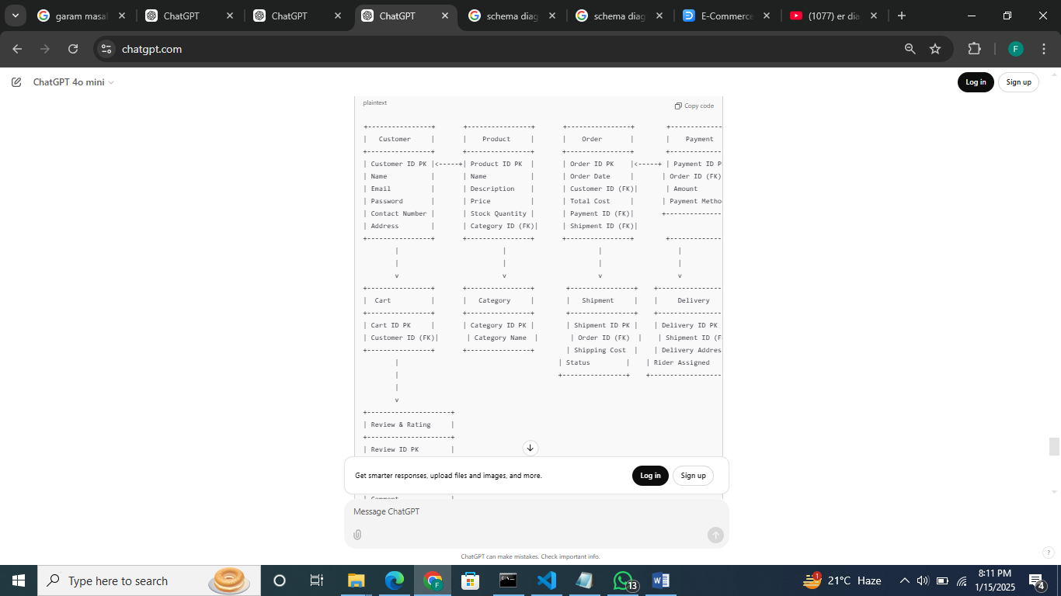

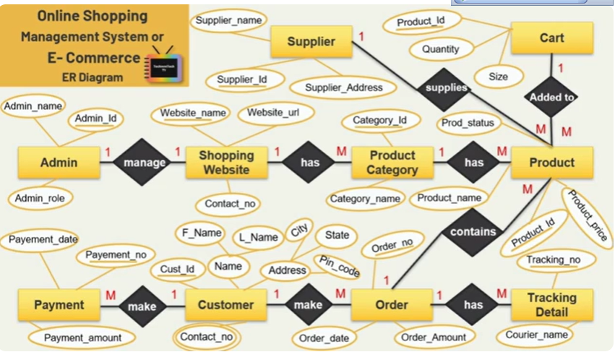

Draw a schmea diagram in which relationship between below entities how they interact with each others.

1. Products

Product ID: Unique ID of each product.

Product Name: The title of the product.

Product Description: Detailed information about the product features, benefits, and usage.

Product Price: The cost of the product, often including discounts, promotions, or bundles.

Product Images: Visual representations of the product from different angles or in use.

Stock/Inventory: Information about the availability of the product.

Package Size: 250 gm , 500 gm , 1000 gm

Product Reviews and Ratings: Customer feedback and scores indicating satisfaction.

Tags : Keyword Reseearch

2. Customers

Customer ID: Unique ID of Customers

Customer name: Name of Customer,

Email ID : email ID of customers

Passward: passward of individual customers

Contact number : contact number of customer

Address: Shipping address of customers

3-Cart

3- Orders:

Order ID: uniques ID of each order

Order Status: Check the progress of order

Order Cost: Total Cost of order

Quantity: Order Quantity

Time & Date of Order placed

4. Payments

Payments ID : unique payment ID

Order ID: order unique ID

Payment Method: Cash On Delivery , Online Payments , Easypaisa

Amount : Total amount of order

5. Shipments

Shipping ID: uniques ID of shipments

Order ID : uniques ID of orders

Shipping Cost: Charges of shipping any location

Status: Live Status of product

6. Delivery

Delivery ADress: Address of customer where to deliver

Coverage Area :

Assigned Rider: Rider who deliver the product.

7. Reviews & Rating

Customer ID: unique customer ID

Order ID: Unique order ID

Product Name :

Product ID: